What is it?

**Other names for L.S.D**

* L.S.D or Lysergic acid diethylamide is a class A hallucinogenic drug, was created in the early 1960s from ergot, a fungus that grows on rye and other grains. LSD is produced in crystalline form before being later diluted into a liquid or being mixed with excipients.
* It is sold in many different forms but are most commonly found in blotter paper(absorbent paper that are dipped with LSD, and are covered in vibrant cartoons, and designs

How common is its use?

* The National Survey on Drug Use and Health(NHSDA) in a 2010 survey found that 71.5% of youth between the ages of 12-17 had great risk of using LSD once or twice a week
* Approx. 12.9% ( about one in seven)of youth indicated that LSD would be fairly easily to come by.
* LSD use is declining in all age groups, particularly due to its intense nature and the likelihood of a “bad trip”.
* LSD users aged 12 and older were 377,000 in 2010 which was similar to the previous of 337,000

**L.S.D**

The truth behind the drug known as

Lysergic acid diethylamide or

**Acid Trip**

Doses  **Hit**

**Haze**

**Yellow sunshine**

**Tabs** sugar cubes

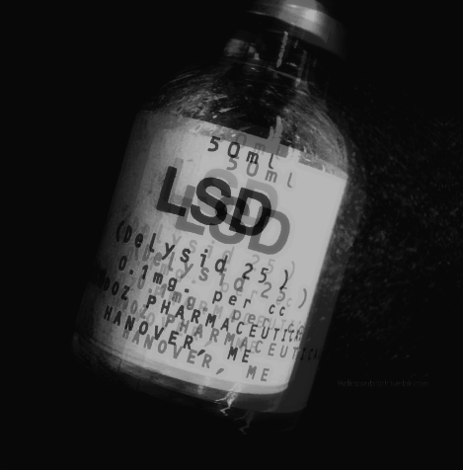

**Abuse Symptoms**

1. Dilated pupils
2. Tremors
3. Confused perception of reality
4. High blood pressure
5. Rapid heart rate
6. Flashbacks; a re-experience of the hallucations even years after the initial “trip”

If you continue to use the drug , it can also led to many other illnesses such as

* Birth defects
* Psychological dependence
* Severe depression
* Schizophrenia

*Stonehenge therapeutic community(in Guelph, ON)*

*Community addiction services of Niagara (St.Cartharines)*

One LSD user online commented the effect LSD had on his life” For the past two years I have been feeling as if I no longer know what to do with my life, what I want out of life, and basically who I am as a person in society. One thing I do know is it killed whatever ego I had at the time .“Even after years after the drug’s initial use, LSD caused this and other fellow users to feel depersonalization, dissociation and derealisation.

If you have decided or are trying to stop taking LSD, That’s a great start! Taking control of your life and taking the first step in the right direction will bring you that much closer to a LSD free life.

*Drugs are not always necessary, but belief on recovery always is*

*1-888-742-83578*

*Narcotics Anonymous*

www.recovery.org

*Where to get help?*

*Here are some support systems in place to help you on your way to a better future!*

*“The secret of change is to focus all of your energy, not on fighting the old, but on the building the new*

LSD brings with it no gain, all it brings is a lot of pain.

*Bibliography=*

1. [*https://answers.yahoo.com/question/index;_ylt=A0LEVivhC5lWQaYAhV8XFwx.;_ylu=X3oDMTBybnV2cXQwBHNlYwNzcgRwb3MDMgRjb2xvA2JmMQR2dGlkAw--?qid=20120112220916AAWbu5t*](https://answers.yahoo.com/question/index;_ylt=A0LEVivhC5lWQaYAhV8XFwx.;_ylu=X3oDMTBybnV2cXQwBHNlYwNzcgRwb3MDMgRjb2xvA2JmMQR2dGlkAw--?qid=20120112220916AAWbu5t)
2. [*http://www.drugs.com/illicit/lsd.html*](http://www.drugs.com/illicit/lsd.html)

With LSD, you don’t feel free, it only gives you captivity.

*800-481-9412*